Secret Book Safe
Sam Houston Area Council
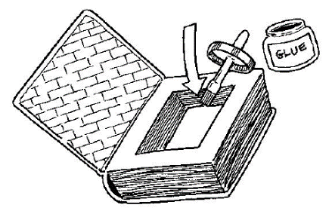
Make a secret place to hide your stuff. You can put money, secret messages, keys, or treasures in the secret compartment. When you close the book and put it on your bookshelf, no one will know it’s a safe – except you!
Materials:
An old hardcover book
Ruler
Pencil,
Hobby knife or scissors
White glue.
Instructions:
- Find a hardcover book that no one wants. It should have at least 200 pages.
- Open the book to the first page.
- Take a ruler and pencil and mark 1 inch from all four sides of the page. Connect the lines to make a rectangle.
- Using scissors or a hobby knife and ruler (with adult supervision and assistance)
- Cut out the shape you just drew, leaving the 1 inch border.
- Repeat steps 2 and 3 with the remaining until the middle sections have been cut out. Be patient – this may take awhile. Try to cut a few pages at a time. When you’re done you should have a rectangle-shaped empty space inside the book.
- Brush white glue along the four walls that line the empty space. You may want to do the same with the outer edges of the page to make them solid.
- Allow the glue to dry. Several coats of glue may be applied one at a time with drying time in between applications.

